Coral Gables Adult
Education Center
Is offering the following class:

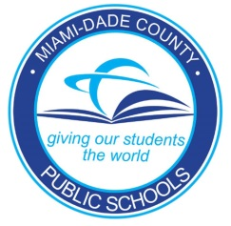
POTTER’S WHEEL FOR BEGINNERS

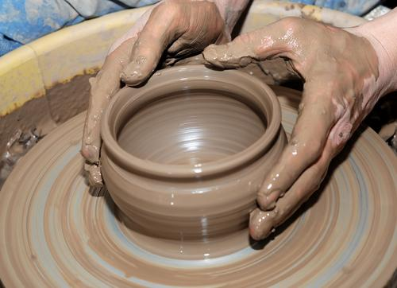

Monday & Wednesday Classes:
January 30th – February15th
6:00 pm to 9:00 pm
at
Coral Gables Adult Education Center
450 Bird Road
Coral Gables, Fl. 33146

Registration: $ 125.00 (includes the firing of all pottery made in class)
Supply cost: $ 30.00 (Student to purchase separately, includes 25 lb. bag of clay & tool kit)

Instructor: Jennifer Stapleton
(studio hours available upon request)

Registration: 450 Bird Rd. Coral Gables, Fl. 33146
Or for more info call: (305) 443-4871 Ext. 2226
Website: www.gablesadult.dadeschools.net

